Westpac NBA Campaign Brief
Campaign Name & DCV if Optimisation | WBC Credit Cards Black Qantas
If Optimisation or Reapproval ONLY  (Select multiple if needed) | NA
Content Owner | Bruce Da Silva
Brand | WBC
Division  (Select multiple if content the same) | C - Consumer
Portfolio | CC - Credit Cards
Campaign Dates/Time | Start Date: ASAP  End Date: Always on
Campaign Type | Sales Trigger: Sales/Utilisation targeting based on customer intent, behavioural data, transactional data, lifecycle of product.
Marketing or Service? | Marketing
User Story | As a customer, I want easy access to up-to-date Westpac credit card offers so that I can confidently select the product that best supports my short-term borrowing requirements.
Hypothesis | By promoting the Altitude Black card to customers, we can increase product awareness and improve the likelihood that they will apply.
Campaign Success Metric | Increase CC Sales/App Completes
Forecast Monthly Sales or Service Events | Monthly Sales forecast (July ’25)  UVs: 2.5k  Clicks: 488  App starts: 96  App completes: 68  Forecasted monthly sales: 70
Approvals | BASE
MDC Risk Rating | High
Audience Description | Customers who have viewed ‘Rewards Qantas’ product pages in the last 15 Days
Audience Brief  Segment names and conditional logic (and/or conditioning) ONLY | Campaign Inclusions:  aam:onsite:wbc:cc:AltitudeQantasBlack-PagesViewed:15D  Campaign Exclusions:  aam:onsite:wbc:cons:cc:AllCreditCards:app-completes:10D  aam:onsite:wbc:cons:cc:hamal:AllCreditCards:app-completes:10D  aam:onsite:WBCCustomerExclns:UniversalCampaign  aam:onsite:WBCCustomerExclns:CreditCardSpecific  Frequency capping
Product | Is this a Product specific/offer based activity? If so, complete the section below:  Provide Product House: Credit Cards  Provide Product Base: Rewards  TMD Search: https://intranet.westpacgroup.com.au/wbc/products-and-services/tmd
TMD

Landing Page or Functional URLs |  | See bottom of doc if landing page required.
ION App | https://www.ui.westpac.com.au/origin/etb0/content/secure-pers/credit-cards/qantas-rewards/altitude-qantas-black/
Desktop | https://www.ui.westpac.com.au/origin/etb0/content/secure-pers/credit-cards/qantas-rewards/altitude-qantas-black/
Mobile Web | https://www.ui.westpac.com.au/origin/etb0/content/secure-pers/credit-cards/qantas-rewards/altitude-qantas-black/

#Please note: Character limits are guides for each field only, if you choose to max out copy in all fields the NBA copy may truncate in Non-Responsive placements.
Component Type – ION App Hero/Pre-auth |  |  | # mandatory
Heading #  (max 56 Char) | Bonus Qantas Points – Altitude Qantas Black card. | 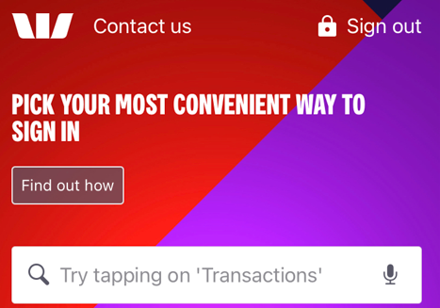
Fine Print  (26 Char) | Min spend credit T&Cs apply
Button Label #  (16 char) | View offer

Component Type – ION App Standard (Responsive tile)  Also used for Desktop Sign Out |  |  | # mandatory
Heading #  (max 48 char)  (max 68 char without icon) | Up to [[Rates#CC|Altitude Qantas Black.CCAQB.BonusPoints{showAsK}]] bonus Qantas Points  Onsite appearance for approvers:  Up to 150K bonus Qantas Points | 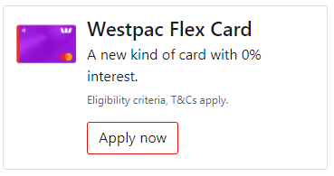  OR  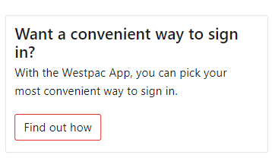
By-Line  (max 72 char)  (max 128 char without icon) | Plus, a $[[Rates#CC|Altitude Qantas Black.CCAQB.ExistingCustomerFYFeeOffer{none}]] card fee in the first year (reverts to $[[Rates#CC|Altitude Qantas Black.CCAQB.AnnualCardFee{none}]] thereafter) with an Altitude Qantas Black card.  Onsite appearance for approvers:  Plus, a $200 card fee in the first year (reverts to $295 thereafter) with an Altitude Qantas Black card.
Fine Print  (max 56 char)  (max 96 char without icon) | Min. spend, credit criteria and T&Cs apply.
Button Label #  (16 char) | View offer
Card art/Icon (optional) | Provide DAM link for creative or supply card art image provided by design team.

Component Type – Mobile Web Expandable (Non-Responsive) |  |  | # mandatory
Heading #  (max 36 char)  (max 40 char without icon) | Up to [[Rates#CC|Altitude Qantas Black.CCAQB.BonusPoints{showAsK}]] bonus Qantas Points  Onsite appearance for approvers:  Up to 150K bonus Qantas Points | 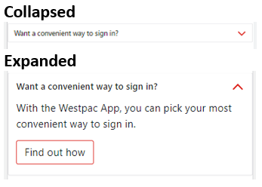
By-Line #  (max 96 char)  (max 128 char without card art) | Plus, a $[[Rates#CC|Altitude Qantas Black.CCAQB.ExistingCustomerFYFeeOffer{none}]] card fee in the first year (reverts to $[[Rates#CC|Altitude Qantas Black.CCAQB.AnnualCardFee{none}]] thereafter) with an Altitude Qantas Black card.  Onsite appearance for approvers:  Plus, a $200 card fee in the first year (reverts to $295 thereafter) with an Altitude Qantas Black card.
Fine Print #  (max 80 char) | Min. spend, credit criteria and T&Cs apply.
Button Label #  (16 char) | View offer
Card art/Icon (optional) | Provide DAM link for creative or supply card art image provided by design team.

Component Type – Desktop Strip (Non-Responsive) |  | # mandatory
Heading #  (max 96 char) | Up to [[Rates#CC|Altitude Qantas Black.CCAQB.BonusPoints{showAsK}]] bonus Qantas Points – Altitude Rewards Black card. Min spend, credit criteria, T&Cs apply.  Onsite appearance for approvers:  Up to 150K bonus Qantas Points – Altitude Rewards Black card. Min spend, credit criteria, T&Cs apply.
Button Label #  (16 char) | View offer

Component Type – Desktop Tile (Non-Responsive) |  |  | # mandatory
Heading #  (max 60 char)  (max 65 char without icon) | Up to [[Rates#CC|Altitude Qantas Black.CCAQB.BonusPoints{showAsK}]] bonus Qantas Points  Onsite appearance for approvers:  Up to 150K bonus Qantas Points | 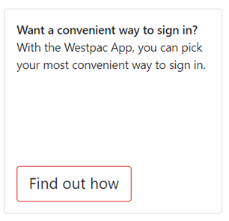
By-Line  (max 100 char)  (max 100 char without icon) | Plus, a $[[Rates#CC|Altitude Qantas Black.CCAQB.ExistingCustomerFYFeeOffer{none}]] card fee in the first year (reverts to $[[Rates#CC|Altitude Qantas Black.CCAQB.AnnualCardFee{none}]] thereafter) with an Altitude Qantas Black card.  Onsite appearance for approvers:  Plus, a $200 card fee in the first year (reverts to $295 thereafter) with an Altitude Qantas Black card.
Fine Print  (max 32 char)  (max 64 char without icon) | Min. spend, credit criteria and T&Cs apply.
Button Label #  (18 char) | View offer
Card art/Icon (optional) | Provide DAM link for creative or supply card art image provided by design team.
#Please note: Final placements determined by campaign type in accordance with channel guidelines.
AEM Landing Page Build
If a landing pages is required to support this campaign request, provide wireframes, copy for landing page including references for AEM components to be used and URLs for any CTA buttons and hyperlinks.

